**Fig 1.1 : USE CASE DIAGRAM**

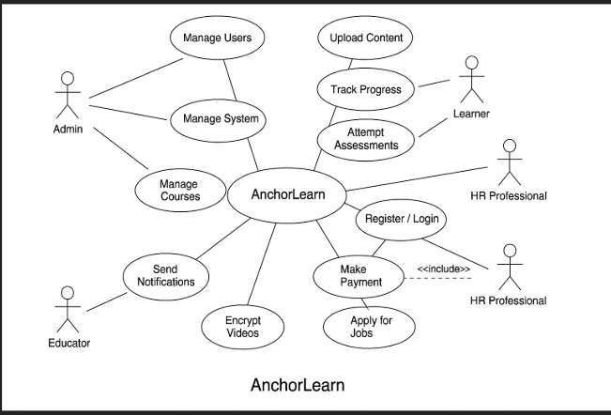

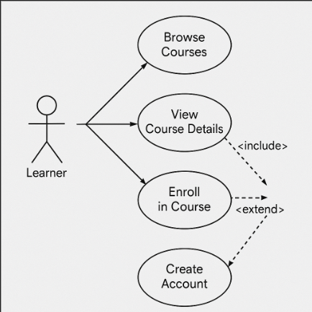

**Fig 1.2 : SYSTEM SEQUENCE DIAGRAM**

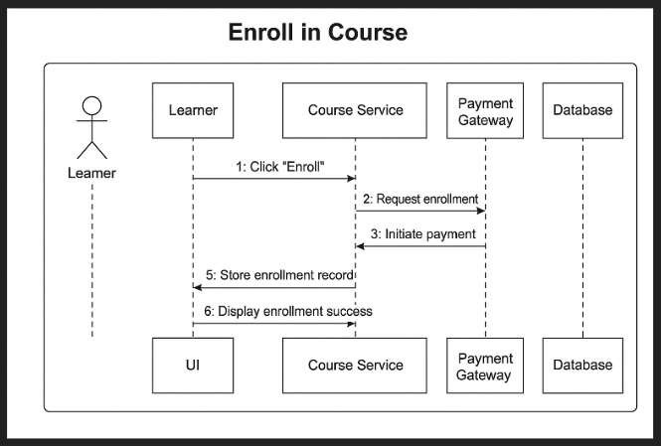

# Fig 1.3 : COMMUNICATION DIAGRAM (USING GRASP)

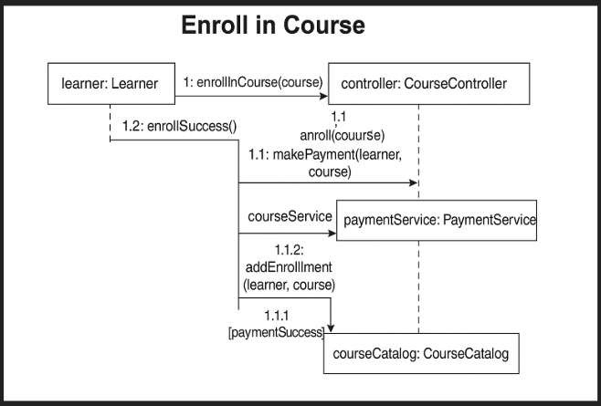

# Fig 1.4 : CLASS DIAGRAM

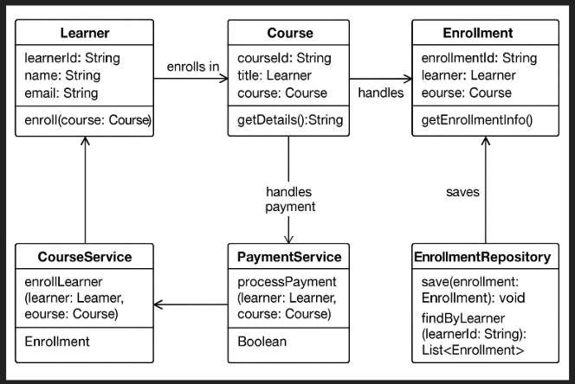

# Fig 1.5: Fully Dressed USE-CASE DIAGRAM

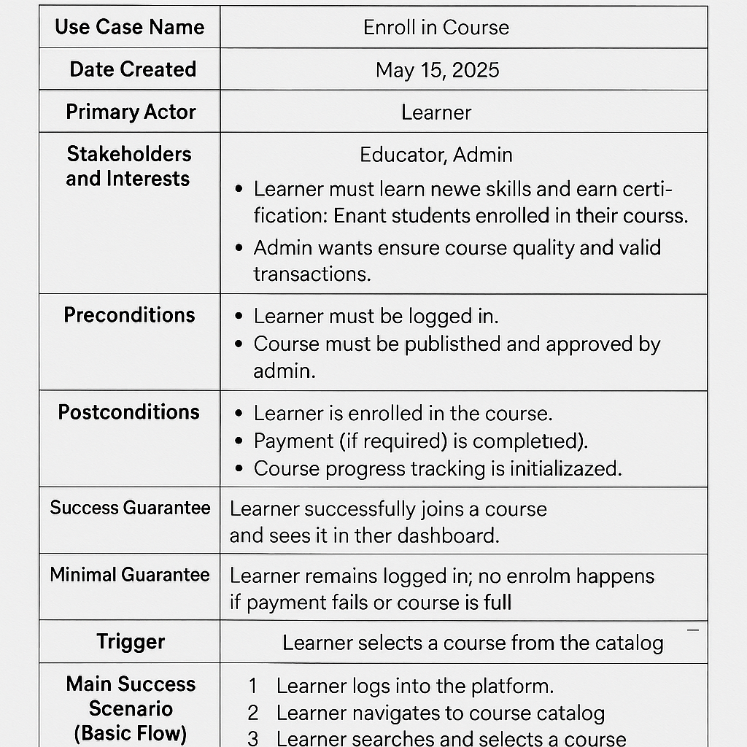

# Fig 1.6: MOCKUP

